

Student Name……………………………………

MATHEMATICAL METHODS (CAS) UNITS 3 & 4

TRIAL EXAMINATION 2

2013

Reading Time: 15 minutes
Writing time: 2 hours

Instructions to students
This exam consists of Section 1 and Section 2.
Section 1 consists of 22 multiple-choice questions, which should be answered on the detachable answer sheet which can be found on page 24 of this exam.
Section 2 consists of 5 extended-answer questions.
Section 1 begins on page 2 of this exam and is worth 22 marks.
Section 2 begins on page 10 of this exam and is worth 58 marks.
There is a total of 80 marks available.
All questions in Section 1 and Section 2 should be answered.
Diagrams in this exam are not to scale except where otherwise stated.
Where more than one mark is allocated to a question, appropriate working must be shown.
If a question requires a numerical answer then an exact value must be given unless a decimal approximation is specifically asked for.
Students may bring one bound reference into the exam.
Students may bring a CAS calculator into this exam.

This paper has been prepared independently of the Victorian Curriculum and Assessment Authority to provide additional exam preparation for students. Although references have been reproduced with permission of the Victorian Curriculum and Assessment Authority, the publication is in no way connected with or endorsed by the Victorian Curriculum and Assessment Authority.

© THE HEFFERNAN GROUP 2013
This Trial Exam is licensed on a non transferable basis to the purchasing school. It may be copied by the school which has purchased it. This license does not permit distribution or copying of this Trial Exam by any other party.
SECTION 1

Question 1

Let 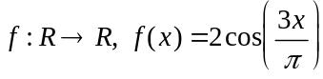.
The period of f is

- 2

- 3

- 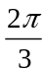
- 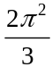

Question 2

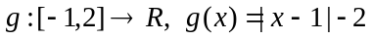.
The range of g is

- 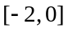
- 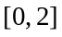
- 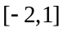
- 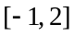
- 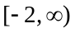

Question 3

The maximal domain and the range of the function 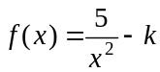, where k is a positive real number, are given by

- 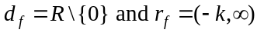
- 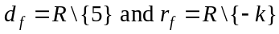
- 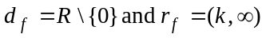
- 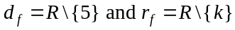
- 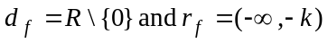

Question 4

The function h can be differentiated for all real values of x.
The derivative of the function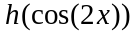 is given by

- 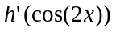
- 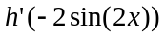
- 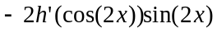
- 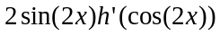
- 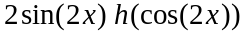

Question 5

The continuous random variable X has a probability density function given by

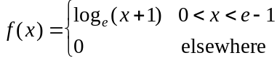

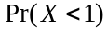 is equal to

- 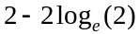
- 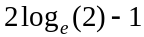
- 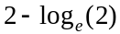
- 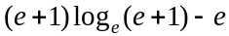

Question 6

The average rate of change of the function 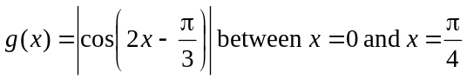 is

- 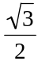
- 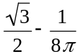
- 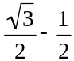
- 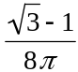
- 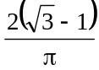
Question 7

The gradient of the normal to the curve 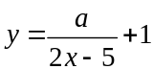 at the point where 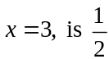.
The value of a is

- 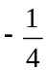
- 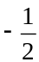

- 1

- 2

Question 8

Let 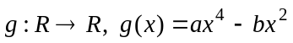 where a and b are positive real numbers.
Also 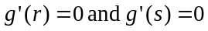 where r and s are real numbers and .
The function g has a positive gradient for

- 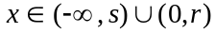
- 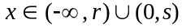
- 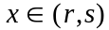
- 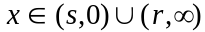
- 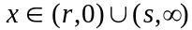

Question 9

An approximation for 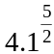 can be found using the linear approximation
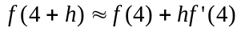 and by considering the point 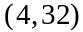 which lies on the graph of 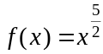.

The approximation is equal to

- 33.5
- 34
- 34.3
- 34.7
- 35

Question 10

Claude walks every day. If he buys a paper on his walk one morning then the probability that he buys one the next morning is 0.4. If he doesn’t buy a paper one morning then the probability that he buys one the next morning is 0.7. Claude bought a paper this morning.
The probability that Claude buys a paper at least once over the next three mornings is

- 0.928
- 0.946
- 0.954
- 0.964
- 0.973

Question 11

The heights of a large group of army recruits are normally distributed with a mean of 179cm and a standard deviation of 5cm.
The tallest 20% of these recruits are invited to trial for a particular unit. The minimum height, in cm, required to be invited to trial for this unit is closest to

- 174.8
- 179.6
- 183.2
- 189.0
- 194.0

Question 12

Let 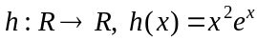.
The average value of h over the interval 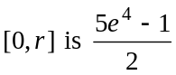.
The value of r is

- 3
- 3.178
- 4
- 4.522
- 5

Question 13

Let 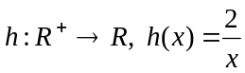.
The area of the region enclosed by the y-axis, the graph of h, and the lines 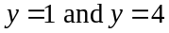 is to be approximated by finding the total area of the three rectangles shown below.
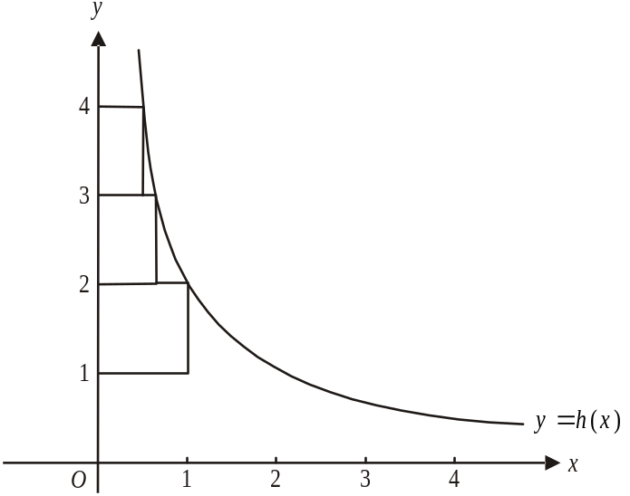

That approximation is equal to

- 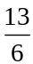
- 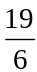
- 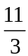
- 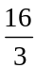

- 9

Question 14

A spherical piece of ice with volume V (in mm³) is melting at the rate of 11.52 mm³ per minute.
When the radius of the sphere is decreasing at the rate of 2mm per minute, the radius of the piece of ice, in mm, is

- 0.69
- 0.80
- 1.20
- 2.73
- 5.71
Question 15

Part of the graph of the function h is shown below.
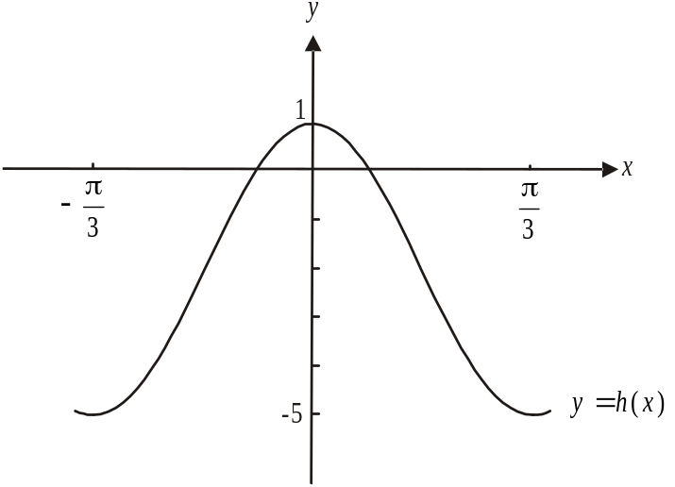

The equation of this graph could be

- 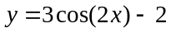
- 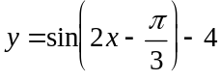
- 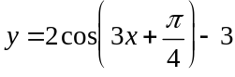
- 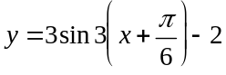
- 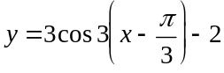

Question 16

The cubic function h has stationary points such that 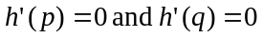. The graph of h passes through the points 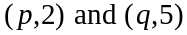.
The equation 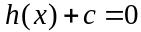 has three solutions if

Question 17

Given that 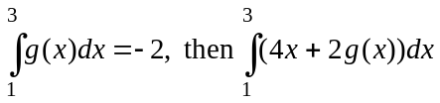 is equal to

- 4
- 12
- 18
- 20
- 30

Question 18

Kevin is a quality control officer on a production line. He is checking plastic car components for faults. The probability that Kevin finds a faulty car component is p where 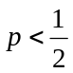.
The probability of one component being faulty is independent of the probability of the next component being faulty.
The probability that three of the next four components he checks are faulty is 0.1536.
The value of p is

- 0.16
- 0.3
- 0.36
- 0.4
- 0.47

Question 19

In a sample space containing the events A and B, 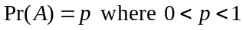.
Also, .
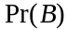 is equal to

- p
- 3p
- 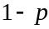
- 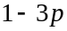
- 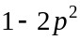

Question 20

The graph of 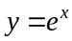 has a tangent at the point 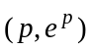. This tangent crosses the y-axis at the point 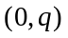. Given that 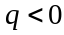, then all the possible values of p are given by

- 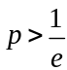
- 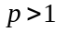
- 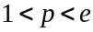
Question 21

The continuous cubic function h has a minimum turning point at the point
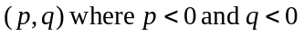 and a maximum turning point at the point 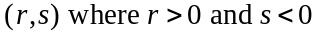.
The graph of the function 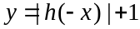 has minimum and maximum turning points located respectively at the points

- 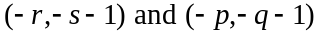
- 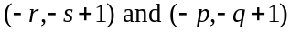
- 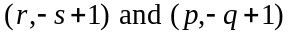
- 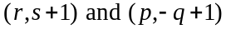
- 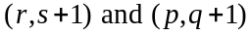

Question 22

For the function f,

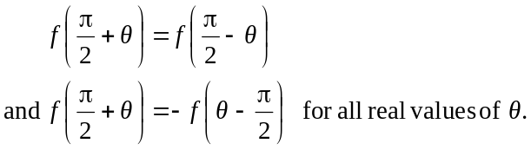

The rule for f could be

- 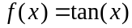
- 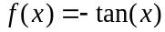
- 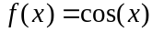
- 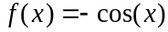
- 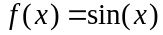

SECTION 2

Answer all questions in this section.

Question 1 (9 marks)

A shampoo container in the shape of a half cylinder, has a height of h cm and a radius of r cm.
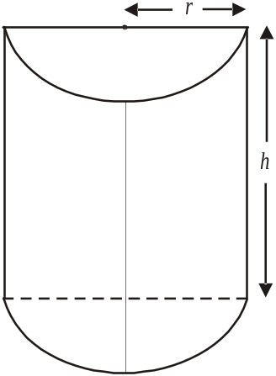

The volume V, in cm³, of the container is 1000cm³ and can be expressed in terms of h and r as

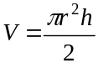.

- Express h in terms of r.
(1 mark)

- Show that the surface area A, in cm², of the container is given by

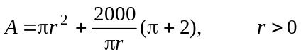.
(2 marks)

- Find 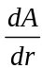 and hence find the exact value of r for which the surface area of the container is a minimum.
(2 marks)

- Find the minimum surface area of the container. Express your answer as an exact value.
(1 mark)

- The shampoo manufacturer decides to change the container. The general shape and volume of the half cylinder is retained but the surface area is to be 800cm² and the radius is to be no greater than 5 cm. Find the height of this new container. Express your answer in cm correct to 1 decimal place.
(3 marks)

Question 2 (13 marks)

Let .

- Over what interval is the graph of f strictly increasing?
(2 marks)

The graph of f undergoes a transformation, 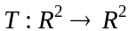, where

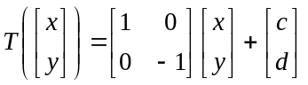

and where c and d are real numbers. The graph of the image function has its turning point located at the origin 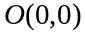.

- Find the values of c and d.
(2 marks)

Suppose the graph of f is dilated by a factor of k from one of the axes. The image graph passes through the point 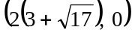.

- Find the value of k.
(2 marks)

- Let .

- Write down the rule for g.
(1 mark)

- Explain why g exists.
(1 mark)

  - Find 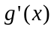.
(2marks)

  - Sketch the graph of 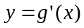 on the set of axes below.
(3 marks)
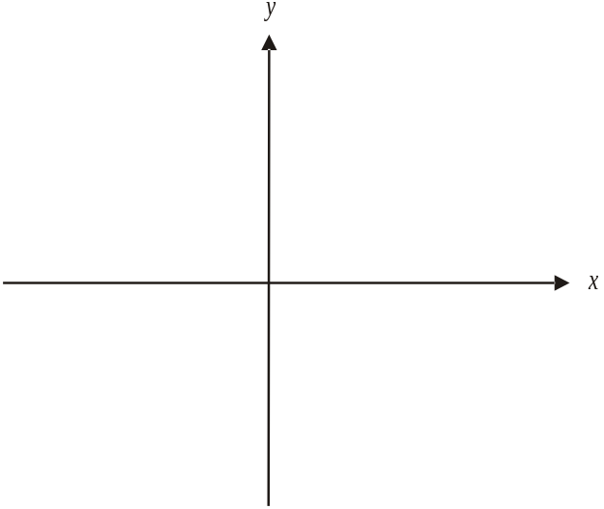

Question 3 (14 marks)

At a supermarket, store data indicates that the probability that a customer has one or more deli items in their purchase is 0.4.

- Sue is an employee at the supermarket and during her shift at a checkout, she serves ninety customers. Let the random variable X represent the number of customers Sue serves who have one or more deli items in their purchases.

- Find the probability that the first four customers that Sue serves don’t have any deli items in their purchase.
(1 mark)

- Find the mean number of customers Sue serves in her shift who have deli items in their purchase.
(1 mark)

- Find the probability, correct to 4 decimal places, that at least thirty of the customers Sue serves have deli items in their purchase.
(1 mark)

Data collected at the store indicates that when an employee at a checkout serves n customers, there is a probability of 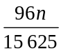 that all but one of those customers will have deli items in their purchase.

- Show that n equals 6.
(3 marks)

Store data also shows that if a customer purchases milk then the probability that the next customer purchases milk is 0.6. If a customer doesn’t purchase milk then the probability that the next customer doesn’t purchase milk is 0.2.
Chris is a supermarket employee and when he opened his checkout, his first customer purchased milk.

c. i. Find the probability that amongst his next four customers, exactly three in succession
didn’t purchase milk.
(3 marks)

ii. Chris serves 60 customers before closing his checkout.
Find the probability that Chris’s last customer purchased milk. Express your answer correct to four decimal places.
(2 marks)

The supermarket is undergoing renovations and has limited shelf space. As a result, some items need to be restocked frequently. The number of times T, in a day that toilet rolls are completely sold out and need to be restocked is a random variable with probability distribution given by

T | 0 | 1 | 2 | 3 | 4
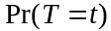 | 0.1 | 0.2 | 0.2 | 0.4 | 0.1

The toilet rolls had to be restocked on both Saturday and Sunday.

- Find the probability that the toilet rolls had to be restocked a total of five times over these two days.
(3 marks)

Question 4 (12 marks)

Victoria James is a spy.
Whilst on a chairlift that spans a valley between two cliffs, her enemies destroyed the control tower causing the chairlift cable to slacken.
As a result, the position of the cable above the ground can be described by the continuous function

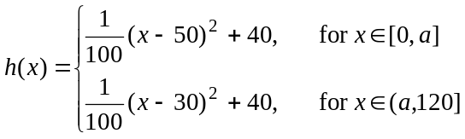

where x represents the horizontal distance in metres of the cable from the base of the left hand cliff and y represents the height in metres of the cable above the ground.
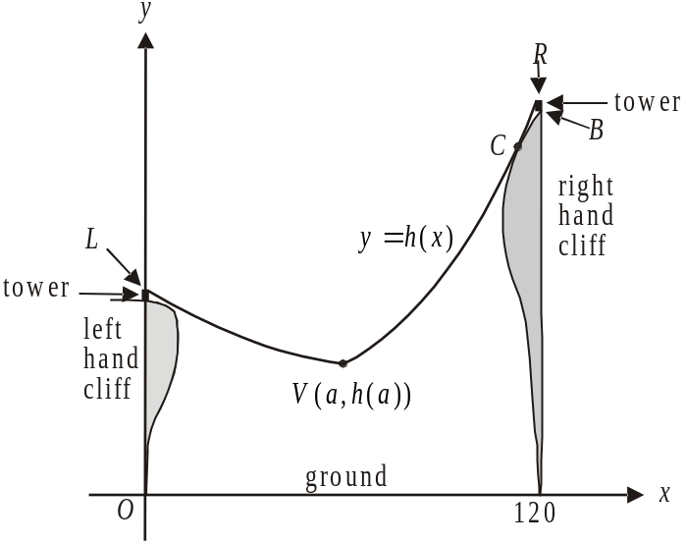

The graph of h is shown above.
The cable is attached to the top of 5m high towers on the left and right hand cliffs at points L and R respectively. The base of the tower on the right hand cliff is indicated by point B.
The cable touches the right hand cliff at point C and starts to fray. Victoria is left stationary at the point 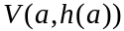.

- Find the value of a.
(2 marks)

- How high is Victoria above the ground?
(1 mark)

The gradient of the cable at point C is 1.48.

- Find the coordinates of point C.
(3 marks)

Victoria has equipment with her that enables her to lower herself to the ground from her stationary position. Let v be her height, in metres, above the ground t seconds after she starts her descent. The rate at which she descends is given by
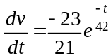.

- i. Find an expression for v in terms of t.
(2 marks)

  - Hence find the time that it takes for Victoria to reach the ground. Express your answer correct to 3 decimal places.
(1 mark)

At the same instant that Victoria starts her descent, an enemy spy who is located at point B, starts to abseil down to point C. He drops 0.24 metres vertically each second. Once at C he takes n seconds to cut the cable.

- i. Find an expression for the total time T, in terms of n, that it takes for him to abseil down from point B and cut the cable.
(2 marks)

  - Assuming Victoria will be safe once she reaches the ground, find the values of n for which Victoria will be safe.
(1 mark)

Question 5 (10 marks)

Let 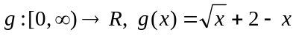. The graphs of 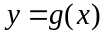 and the line with equation 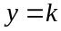, where k is a positive constant, are shown below.

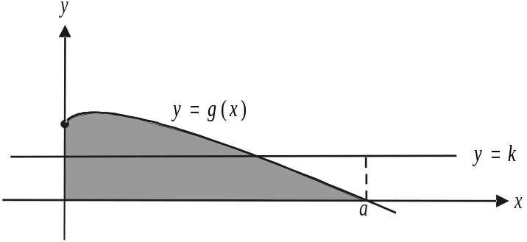

The graph of g has an x-intercept at the point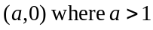. The area enclosed by the graph of and the x and y axes is shaded.

- Show that
(2 marks)

- Find the values of k for which there is one point of intersection with the line and the graph of .
(2 marks)

- If the area enclosed by the lines with equations 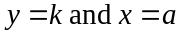 and the x and y axes, is equal to the area of the shaded region, then find the value of k.
(2 marks)

- Find the area of the shaded region.
(1 mark)

The graphs of 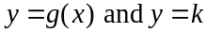, intersect at a point where 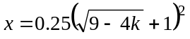.

- Find the value of k for which the area of the shaded region above the line is equal to the area of the shaded region below the line . Express your answer correct to 2 decimal places.
(3 marks)

Mathematical Methods (CAS) Formulas

Mensuration
area of a trapezium: 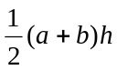 volume of a pyramid: 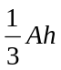
curved surface area of a cylinder: 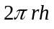 volume of a sphere: 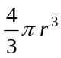
volume of a cylinder: 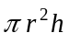 area of a triangle: 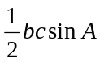
volume of a cone: 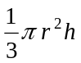

Calculus
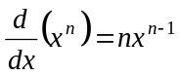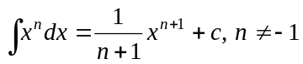
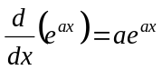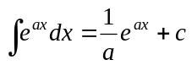
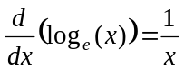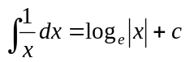
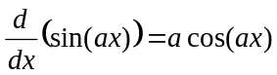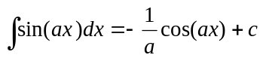
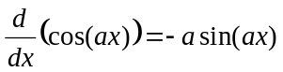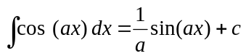
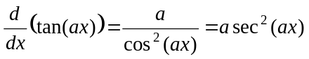
product rule: 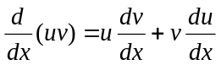 quotient rule: 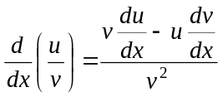
chain rule: 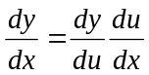 approximation: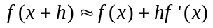

Probability
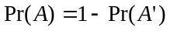
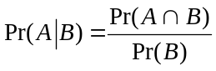 transition matrices: 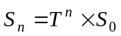
mean: 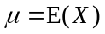 variance:

probability distribution |  | mean | variance
discrete | 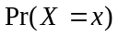=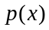 | 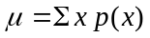 | 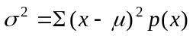
continuous | 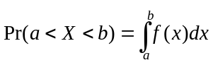 | 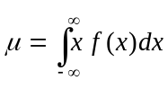 | 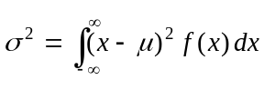
Reproduced with permission of the Victorian Curriculum and Assessment Authority, Victoria, Australia.
This formula sheet has been copied from the VCAA website www.vcaa.vic.edu.au
